Darwin Pena Cabrera
WEB340-306O Node.js
DATE: 05/20/2026
First of all, I will add a picture of the npm test before and after the AI changes.

Before:
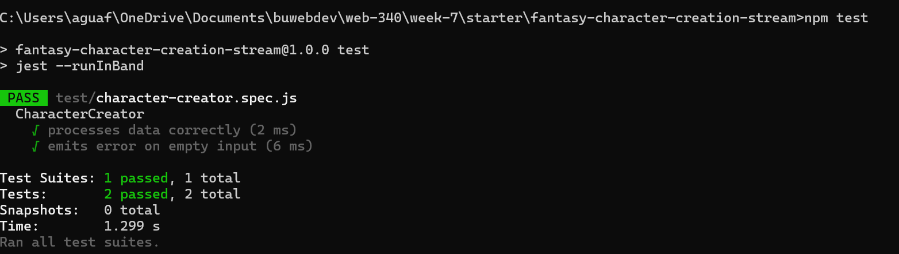

After:
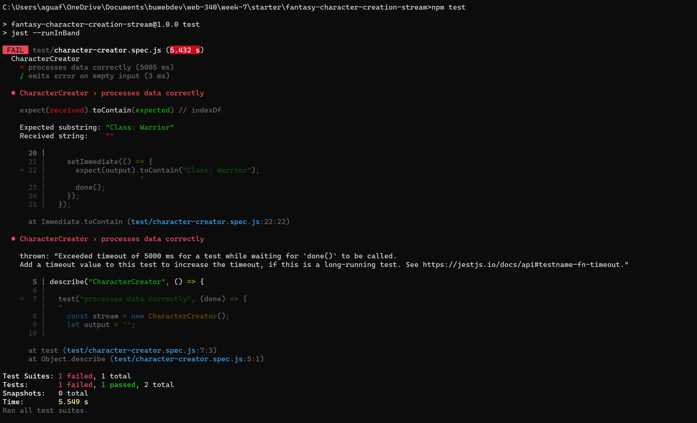

From the test, the first evident change is that after the changes, the code is taking longer to complete the tasks, which triggers a failed test due to missing the requirements of the following lines:
setImmediate(() => {
expect(output).toContain("Class: Warrior")
done();

since the setImmediate function runs before the setTimeout function
setTimeout(() => {
this.push(formatted);
callback();
}, 100);

The test is not getting the expected data on time; in fact, on average, it is taking more than 5 seconds, whereas before the changes, it was taking a little more than a second.

Additionally, the AI added "this.lastCharacter = null;" and "this.lastCharacter = input", which store the last character and make it available for use in the following lines.

Changed the class, gender, and fun fact from input values to the data that was collected for the last character by using this.lastCharacter instead of input values.

Lastly, the AI introduced an async processing delay, which caused the npm test to fail.

The shared state is set in the following line: "this.lastCharacter = null;" and then updated in the next line: "this.lastCharacter = input;". The introduction of both lines introduces the concept of shared data, allowing all writers to share the same last-character data.

By setting a 100ms delay in the setTimeout function, the code no longer processes the information immediately, allowing queued processes to overlap. Additionally, the timing can lead to complications, such as race conditions or unexpected changes. For example, if another write is introduced during the delay, it will overwrite the last character.

The instability of the AI changes comes from the setTimeout function, which allows multiple writes to occur before the delay finishes, overwriting the lastCharacter. By the time the delay finishes, the current data might no longer match the input that initiated the delay.

This matters in production because the delay creates inconsistencies and unpredictability. Before the shared state, results were isolated, but now the same input can produce unexpected results due to data-loading timing; this inconsistency also makes it harder to fix bugs and errors.

